**DEAL CHECKER**

***A Major Project Report in partial fulfillment of requirements for the degree of***

***Master of Computer Application***

***Submitted***

***By***

**Chandan Pradhan**

**Regd. No. – 2206151030**

***Under the Guidance***

***Of***

**Dr. Suvasini Panigrahi**

Associate Professor

Department of Computer Science & Engineering

Veer Surendra Sai University of Technology, Burla, Odisha

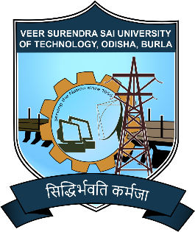

**DEPARTMENT OF COMPUTER APPLICATION**

VEER SURENDRA SAI UNIVERSITY OF TECHNOLOGY, BURLA, ODISHA - 768018, INDIA

May 2024

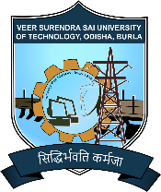**Department of Computer Application**

**VEER SURENDRA SAI UNIVERSITY OF TECHNOLOGY**

(Formerly, University College of Engineering)

SIDHI VIHAR, BURLA – 768018

**DECLARATION**

I certify that,

* The work contained in this thesis is original and has been done by me under the guidance of my supervisors.
* The work has not been submitted to any other Institute for any other degree or diploma.
* I have followed the guidelines provided by the university in preparing the thesis.
* Whenever I have used materials (data, theoretical analysis, Figures, and text) from other sources, I have given due credit them in the text of the thesis and giving their details in the references.

**Chandan Pradhan**

**Department of Computer Application**

**VEER SURENDRA SAI UNIVERSITY OF TECHNOLOGY**

(Formerly, University College of Engineering)

SIDHI VIHAR, BURLA – 768018

**CERTIFICATE**

This is to certify that the project entitled **Deal Checker,** submitted by **Chandan Pradhan** bearing registration no. 2206151030 to Department of Computer Application, Veer Surendra Sai University of Technology, Burla, Odisha, India, for the award of degree of **Master of Computer Application**, is a record of an original project work carried out by them under my supervision and guidance. The project fulfills all the requirements as per the regulations of the university and in our opinion. It has reached the standard needed for submission. Neither this project nor any part of it has been submitted for any degree or academic award elsewhere.

**Dr. Satyabrata Das**

H.O.D

Department of CA

VSS University of Technology

Burla, Odisha

**Dr. Suvasini Panigrahi**

Internal Guide

Department of CSE

VSS University of Technology

Burla, Odisha

**External Examiner**

**Department of Computer Application**

**VEER SURENDRA SAI UNIVERSITY OF TECHNOLOGY**

(Formerly, University College of Engineering)

SIDHI VIHAR, BURLA – 768018

**ACKNOWLEDGEMENT**

The enduring pages of the work are the cumulative sequence of extensive guidance and arduous work. I wish to acknowledge and express my personal gratitude to all those whom this work could not have been reality. First, I express my heartiest devotion to “Almighty God” for his graceful blessings at every step without which nothing could have been reality. I feel very delighted to get this rare opportunity to show my profound senses of reverences and indebtedness to my esteemed guide **Dr. Suvasini Panigrahi** (Project Coordinator) and **Dr. Satyabrata Das** (HOD CA) for their keen and sustained interest, valuable advice, throughout the course of which led my new technology analysis, to a successful completion. For this kind act of consideration, I am beholden to them in a special manner, and no one can fully convey my feelings of respect and regard for them. I can’t express my thanks in words for my parents who given me this opportunity and family members for their great support and love. Finally, I would like to thank those who have directly or indirectly helped and co-operated in completing this report.

**Chandan Pradhan**